Table of contents
1. Document purpose 1
2. Productivity measurement value 1
3. Priority of tasks and productivity using task priority 1
3.1.1. Individual productivity 3
3.2.1. Team productivity 7
4. Productivity on team view using score only 8

Document purpose
- The purpose of this document is to specify the method to be measured productivity of team. Provides information support reader to understand why and how to define productivity of organization (team) and provide some resolution to be used in improving productivity in future work.
- The data provided in this assignment which is obtained from the Effort log, meeting minute and evaluate member table of team were collected weekly.
- Outputs (products) of team assignment are used to measure are document, tasks and earned score.

Productivity measurement value
- To help PM balance members workload and project capacity
- To help PM objectively evaluate assigned tasks, task time and complexity, and even members experience levels to more accurately assess individual workload and capacity. The result is a simple but useful representational graph
- To help PM define the standard for a perfect team
- To help PM make decision to improve team or individual performance

Priority of tasks and productivity using task priority
  - For individual
- Each assignment, we divide them into tasks. To evaluate size of work we base on completed tasks in before assignments. But problem is all tasks in assignment are not the same so define priority for each task is necessary.
- Evaluate spent effort for each task of each assignment will help us to define productivity of team based on individual productivity.
- The following table will describe priority and point of each task in all team assignments. (Statistics base on history data of team)
Assignment | Task | Point | Role
1 | Make roles and responsibility | 1 | Tin
1 | Make process | 1 | Son
1 | Schedule for 15 weeks | 1 | Tam
1 | Review & integrate | 1 | Huyen
1 | Review schedule for 15 weeks | 1 | Van
1 | Review & correct all | 3 | Van
2 | Make assignment | 3 | All (no Leader)
2 | Integrate | 1 | Huyen
2 | Review & correct all | 3 | Van
3 | Make assignment | 3 | All (no Leader)
3 | Integrate | 1 | Son
3 | Review & correct all | 3 | Van
4 | Make assignment | 3 | All (no Leader)
4 | Integrate | 1 | Tam
4 | Review & correct all | 3 | Van
5 | Make WBS | 1 | All(no Leader)
5 | Schedule | 3 | All(no Leader)
5 | Network diagram | 1 | All(no Leader)
5 | Integrate | 1 | Tin
5 | Review & correct all | 3 | Van
6 | Individual productivity | 2 | Tin
6 | Team productivity | 2 | Son
6 | How to improve productivity | 2 | Tam
6 | Integrate | 1 | Huyen
6 | Review & correct all | 3 | Van

- How can we know priority of these tasks? – We base on the complexity of this task. Example: with assignments that cannot be divided into tasks, the complexity of it is HIGH, so its point is 3. And if can be divided into task, each this task just has 1 point. But in some special task, we must use brain storming method to make decision how many point for each task.
- Example for using (metrics): in assignment 1, Tin and Son do 2 tasks have same priority. Tin spent 2 hours for his task; Son spent 4 hours for his task. We get Tin’s (or Son) score multiply with his task priority point and divide into his spent hour :
- TIN: Score is 475. Productivity = 475*1/2
- SON: Score is 950. Productivity = 950*1/4
- 2 results are same. So their performance is the same. But if Tin spent hour is 4 hours then productivity of Son is higher than Tin.
Metric: Score of member * priority point of his (or her) task / spent hour
- Bring result to compare to the other members, the higher score, the higher performance.

Individual productivity
Name | Ass | Productivity | Representational Chart
Le Dinh Thach Huyen | 1. | 675*1/7  = 96.43 | 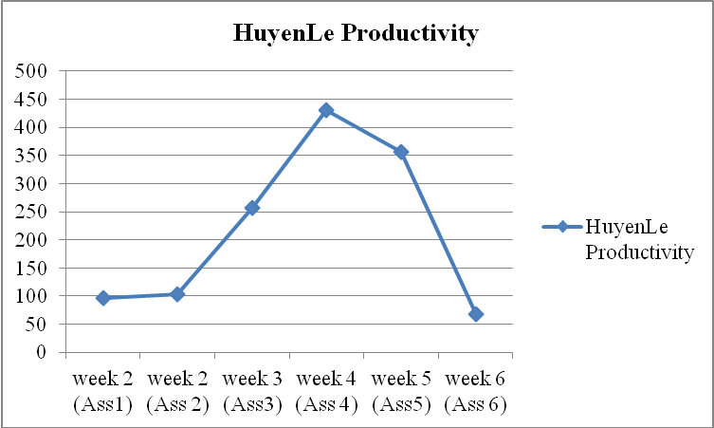  Evaluation:  High productivity (>500) in week 4,5  Medium productivity (200-500) in week 3  Low productivity (<200) in week 2 (Ass1&2),6  - Solutions:  + To need make little contribution when working with team : to active discuss, contribute ideas to Team, ...  + Lack skill: analysis requirement, control time for doing team work, wase so much time. So need to improve  + To train skill documentary more better  + To need more and more effort when woring with team and do team homework  + Communication is not good. So need to improve
Le Dinh Thach Huyen | 2. | 700*1/6.75  = 103.7
Le Dinh Thach Huyen | 3. | 450*3/5.25  = 257.14
Le Dinh Thach Huyen | 4. | 925*3/6.45  = 430.23
Le Dinh Thach Huyen | 5. | 925*5/13  = 355.77
Le Dinh Thach Huyen | 6. | 875*1/13  = 67.31
Dang Huy Son | 1. | 950*1/7.5  = 126.67 | 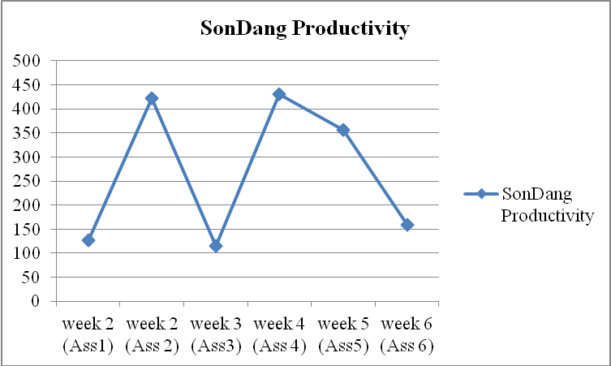  Evaluation  High productivity (>500) in week 2 (Ass2),4,5  Medium productivity (200-500)  Low productivity (<200) in week 2 (Ass1),3,6  - Problem – Weakness:  + Lack skill control time, need to use efective effort log. So need to improve  + To train skill documentary more better
Dang Huy Son | 2. | 950*3/6.75  = 422.22
Dang Huy Son | 3. | 950*1/8.25  = 115.15
Dang Huy Son | 4. | 925*3/6.45  = 430.23
Dang Huy Son | 5. | 1000*5/14  = 357.14
Dang Huy Son | 6. | 950*2/12  = 158.33
Do Minh Tam | 1. | 950*1/9.75  = 97.44 | 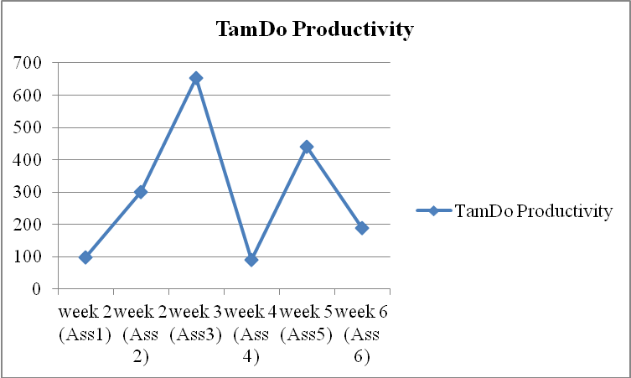  Evaluation:  High productivity (>500) in week 3,5  Medium productivity (200-500) in week 2 (Ass2)  Low productivity (<200) in week 2 (Ass1),3,6  - Problem - Weakness:  + Control time for do team work, analysis requirement  + To try to limited impact of problems from family
Do Minh Tam | 2. | 950*3/9.5  = 300
Do Minh Tam | 3. | 925*3/4.25  = 652.94
Do Minh Tam | 4. | 950*1/10.45  = 90.91
Do Minh Tam | 5. | 550*5/6.25  = 440
Do Minh Tam | 6. | 825*2/8.75  = 188.57
Nguyen Trung Tin | 1. | 475*1/8  = 59.38 | 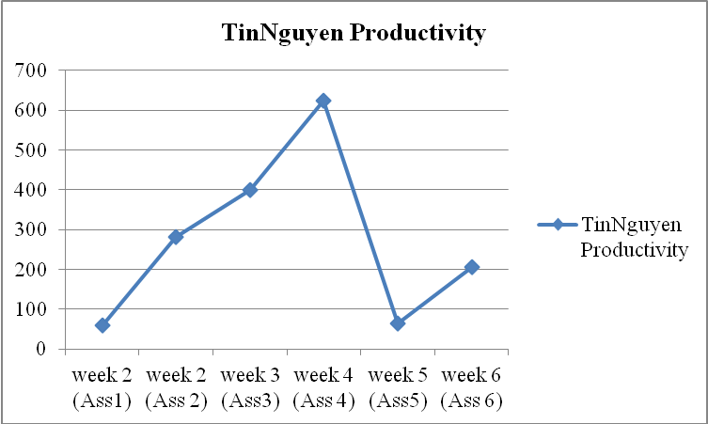  Evaluation :  High productivity (>500) in week 4  Medium productivity (200-500) in week 2(Ass2) 3,6  Low productivity (<200) in week 2 (Ass1),5  - Problem – Weakness:  + Control time do team work, analysis requirement and  + Not to effort when working with team and do team homework. Not focus to discussed with team to understand issues so document of task assigned usually rambling  + Not to make the most of time for working team homework. So need to improve
Nguyen Trung Tin | 2. | 725*3/7.75  = 280.65
Nguyen Trung Tin | 3. | 500*3/3.75  = 400
Nguyen Trung Tin | 4. | 925*3/4.45  = 623.6
Nguyen Trung Tin | 5. | 650*1/10  = 65
Nguyen Trung Tin | 6. | 725*2/7  = 207.14
Le Thi Bich Van | 1. | 950*4/11  = 345.45 | 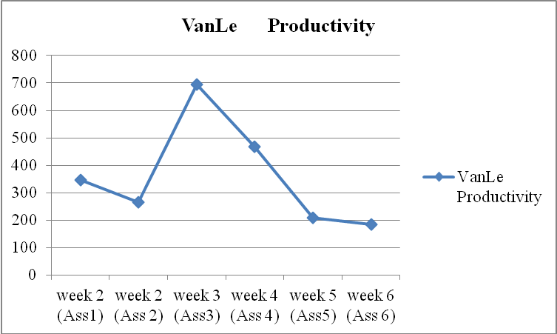  Evaluation  High productivity (>500) in week 2 (Ass 1&2),3,4  Medium productivity (200-500)  Low productivity (<200) in week 5,6  - Problem - Weakness:  + Control time for do team work  + Need to improve skill in team work and balance workload between members  + Need to help members of team to work highest possible performance
Le Thi Bich Van | 2. | 950*3/10.75  = 265.12
Le Thi Bich Van | 3. | 925*3/4  = 693.75
Le Thi Bich Van | 4. | 925*3/5.95  = 466.39
Le Thi Bich Van | 5. | 975*3/14  = 208.93
Le Thi Bich Van | 6. | 950*3/15.5  = 183.87

  - For team
- Like metric for individual.
Metric: Score of team * total priority point of this assignment / total spent hours of all members
- Result of metric is bring to compare to the other teams or compare to plan, the higher score, the higher performance.
- There are three standards to evaluate productivity
- Evaluate productivity against the planned
    - Example: Implementation plan is 4 hours but actually is 2 hours. So increased productivity
- Evaluation productivity of this assignment with the previous assignment
    - Example: Implementation this assignment is 6 hours but actually is 5 hours. So increased productivity if score of two assignments are equal.
- Evaluate productivity between the teams. We get the productivity of the best team and productivity of the worst team divide into 2. That is our standard.

Team productivity
Ass | Productivity Team | Representational Chart
1. | 92.49 | 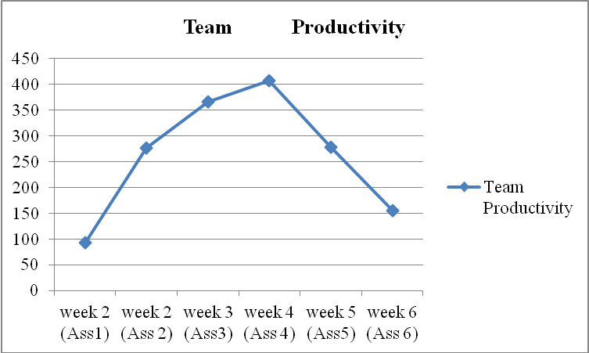  Evaluation  High productivity (>500)  Medium productivity (200-500) Week 2(Ass2),3,4,5  Low productivity (<200) in week 2 (Ass1),6
2. | 276.84
3. | 366.67
4. | 407.78
5. | 278.60
6. | 155.11

Productivity on team view using score only
- Productivity is a measurement; help developers measure their effectiveness of work. The simplest way to define productivity is measure OUTPUT/INPUT. In software, this is SIZE/EFFORT. But define exact size or effort in software is a hard work.
- In this assignment, we have to define what is the size and effort of our team work.
- The size of work can be measured by output of it. We assume our output (product) is score of this assignment. The higher score, the bigger size.
- The effort of work can be measured by number of spent hour in assignment of all members.
- I will describe how I can give my idea about productivity in following picture. Using GQM approach.
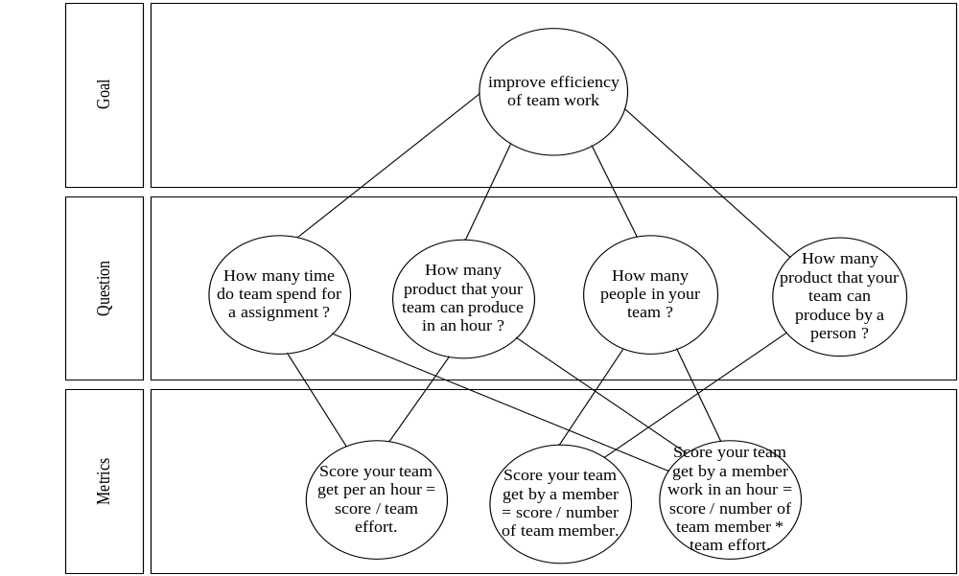
- With above set of metrics we can use to measure our team effectiveness, and bring our measurement results compare to the others team.

